Computer Language Coding Concepts

Objects Floating Around in a Diagram
The concept of objects floating around is explained in the article Objects Floating Around. The current article further demonstrates the concept with diagrams.

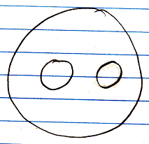

The smaller circles are references to objects, even though the bigger object seems to be the sole container of the objects themselves. You do not see the actual objects. You are only seeing references to it.

Another symbol can start referring to the same object, making the object all of a sudden not part of a unique container anymore.

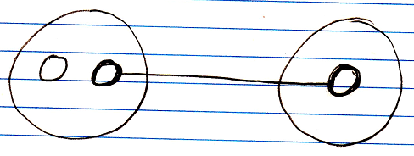

When you annul the object reference in the original parent, the second parent all of a sudden becomes the sole container of the object.

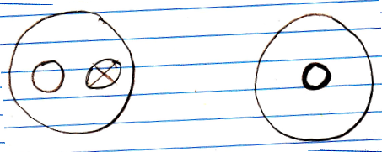

The object has moved from one parent to another.

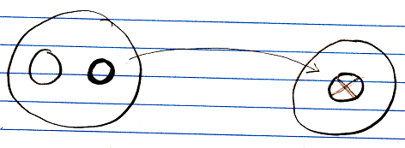

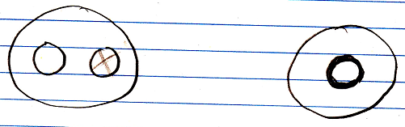

Objects are always just floating around like that. They don’t have to stay in a fixed spot.

See also: System Objects, Objects Floating Around

Author & Copyright: Jan-Joost van Zon Date: July 18, 2008 – July 18, 2008 Location: Oosterhout, The Netherlands Status: Finished

